**HOMEWORK**

LOGIC REVIEW BEFORE MIDTERM EXAM

**Exercise 1:**

The alphabet is given below to help you:

a b c d e f g h i j k l m n o p q r s t u v w x y z

**Q1** a w b ? c o ?=S

**Q2** e e z ? y o o ?=X

**Exercise 2:**

**Q1** An ASCII represents 245 characters. What is the size (in bits) of an ASCII? *(Justify your answer)*

Answer 1: It need 9bit to store because 245 characters need 9bit (29=256) that have more 245.

**Q2** with 8 bytes, how many values can be represented? *(Justify your answer)* ​

With 8 bytes, values can be 64bit (8byte*8bit=64bit)

**Q3** How many bits to store alphabet and number in keyboard 0…9, A…Z and a…z

1. For number in keyboard 0-9 need to 4bit to store because 24=16 that can store number keyboard that have more 10 numbers. So it can’t store 3bit because 3bit =8 .

**Exercise 3:**

**Q1** What is the result of this operation with binary numbers? ​

1011 0101

- 0101 1110

________________

0101 0111

**Q2** What is the result of this operation with binary numbers? ​

1111 0011

- 0111 1101

- 0011 1011

_________________

0011 1001

**Q3** What is the result of this operation with binary numbers? ​

1011 0011

- 0101 1101

- 0011 1011

- 0001 1000

________________

0001 0011

**Q4** What is the result of this operation with binary numbers? ​

1011 0101

+ 0111 1111

________________

10011 0100

**Q5** What is the result of this operation with binary numbers? ​

1111 0011

+ 1001 1101

+ 0111 1011

_________________

100000 1011

**Q6** What is the result of this operation with hexadecimal numbers?

D2F7

+ CF84

+ 3CDE

_____________

1DFD7

**Exercise 4:**

Compute the following conversions

|  |  |
| --- | --- |
| Base 2 | Base 10 |
| 101101 | *Explanation:*1*25+0*24+1*23+1*22+0*21+1*20= 4510 |

|  |  |
| --- | --- |
| Base 2 | Base 16 |
| 101101 | *Explanation:* 2D |

|  |  |
| --- | --- |
| Base 16 | Base 8 |
| D8F | *Explanation*:  1101100011112 =66178 |

|  |  |
| --- | --- |
| Base 16 | Base 2 |
| D8F | *Explanation*:  1101000011112 |

**Exercise 5:**

**Q1. Rules:**

* First 3 characters “AOU”, repeated many times (max repetition is 20)
* In the end you can have X, Y or Z, only one letter

Examples:

AOUAOUX

AOUY

AOUAOUAOUAOUX

1. Explain your encoding

|  |  |  |
| --- | --- | --- |
| Meaning | Encording to deciaml | Encording to binary |
| ចំនួនពាក្យអាចមានពីមួយពាក្យដល់ម្ភៃពាក្យ | 1,2,...20 | 01, 10, 10100 |
| ចំនួនអក្សរនៅខាងក្រោយ | X= 0  Y=1  Z=2 | 00  01  10 |

1. Give examples : 110 01 = AOUAOUAOUAOUAOUAOUY

10 10 = AOUAOUZ

1. Explain the size = 5BIT*2= 10BITS

**Q2. Rules:**

* 3 signs: @, #, %
* The sign is any order
* Each sign is repeated the same number of times, maximum of repetition is 5
* In the end you can have A, B or C, only one letter

Examples:

@@###A

%%@@@@@#B

1. Explain your encoding, give the example and your explanation

|  |  |  |
| --- | --- | --- |
| meanning | Encoding to deciaml | Encoding to binary |
| ចំនួនសញ្ញា | @ = 1,2,3,4,5  # = 1(6)  2(7)  3(8)  4(9)  5(A)  %= 1(B)  2(C)  3(D)  4(E)  5(F) | 001,010,011,100,101  0110  0111  1000  1001  1010  1011  1100  1101  1110  1111 |
| អក្សរនៅខាងក្រោយ | A =1  B =2  C =3 | 01  10  11 |

1. For this example, **%%%%%**C, what is the littlest size possible with your encoding?

%%%%%C = 1111 11

And the littlest size possible with encoding are 6bit.

##%%@@A = 0111 1100 010 01

1. Explain the size

It need 96bits (3bit *4bit* * 4bit *2bit)

**EXERCICE 6: Encoding problem**

**Rules:**

* 4 letters: A, B, C, D
* Any order
* Maximum of repetition is 14

Examples:

ABCD

DBCAA

ADABCAA

1. Explain your encoding

|  |  |  |
| --- | --- | --- |
| meaning | Encoding decimal | Encoding binary |
| អក្សរ​ | A=1  B=2  C=3  D=0 | 01  10  11  00 |
| ចំនួនអក្សរ | 1,2,...,14 | 0001,0010,...,1110 |

1. Give examples

11 1000 =CCCCCCCC

1. Explain the size

It need 8bits =2bit *4bit

**EXERCICE 7: Encoding problem**

**Rules**:

* First 2 characters “AB”, repeated many times (max repetition is 5)
* Then 1 character “*”, repeated many times (max repetition is 5)
* Then 1 number (0-9)

Examples:

ABABAB***8

AB*****7

ABABAB*****3

1. Explain your encoding

|  |  |  |
| --- | --- | --- |
| meanning | Encoding to deciaml | Encoding to binary |
| ចនួនដងនៃអក្សរAB | 1  2  3  4  5 | 001  010  011  100  101 |
| ចំនួនដងសញ្ញា* | 1  2  3  4  5 | 001  010  011  100  101 |

|  |  |  |
| --- | --- | --- |
| ចនួនលេខ | 0,1,2,....,9 | 0000,0001,0010,0011,.....,1001 |

1. Give examples

11101000= ABABAB***8

AB*****7 =001 101 0111

1. Explain the size

It needs 36bits =3bit*3bit*4bit

**EXERCICE 8: Encoding problem**

**Rules:**

* 4 letters: A, E, O, U
* Each letter is repeated minimum 0 time and maximum 7 times.
* The letters are always in the alphabetic order: A then E then O then U

Examples:

AAAAEEEOOU

EEEUUUUUUU

AAEEOOUU

1. Find an encoding of maximum **12 bits**. Explain the method, explain the size and give examples.

|  |  |  |
| --- | --- | --- |
| meaning | Encoding to decimal | Encoding to binary |
| ចំនួនដងនៃអក្សរនីមួយ | A = 1-7  E = 1-7  O = 1-7  U = 1-7 | 001,..,111  001,..,111  001,..,111  001,..,111 |

So it have for letters that one letter can have 1-7

And the size have 3BIT

For example AAAAEEEOOU= 100 011 010 001

1. Is your encoding lossless or loosely?

It is lossles.

**EXERCICE 9: Encoding problem**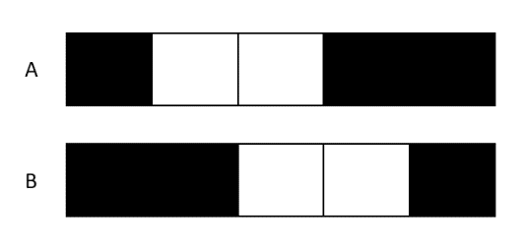

**Rules:**

* The image has only 2 options A & B

Question - Find an encoding

|  |  |  |
| --- | --- | --- |
| Meaning | Encoding to decimal | Encoding to binary |
| Option | A =1  B =0 | 1  0 |

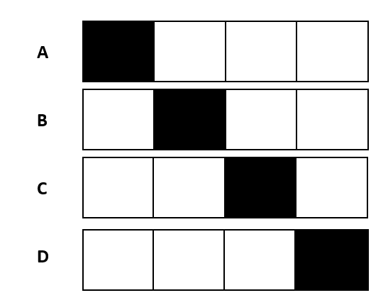

**EXERCICE 10: Encoding problem**

**Rules:**

* The image has only 4 options A, B, C, D

Question - Find an encoding

|  |  |  |
| --- | --- | --- |
| Meaning | Encoding to decimal | Encoding to binary |
| Option | A= 10  B= 11  C= 12  D= 13 | 1010  1011  1100  1101 |

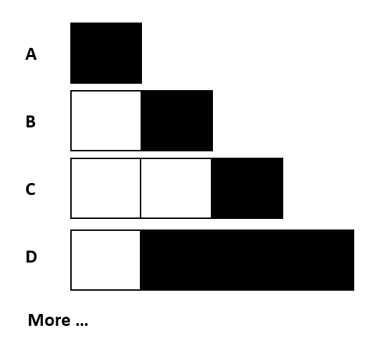

**EXERCICE 10: Encoding problem**

**Rules:**

* The image has 1 to 4 pixels
* 1 to 3 black pixels
* The black pixels shall be together

Question - Find an encoding

|  |  |  |
| --- | --- | --- |
| Meaning | Encoding to deciaml | Encoding to binary |
| Mumber of image | 1,2,3,4 | 001,010,011,100 |
| Mumber of black pixel | 1,2,3 | 001,010,011 |
| Position | 1,2,3,4 | 001,010,011,100 |

Example: 100 01 10

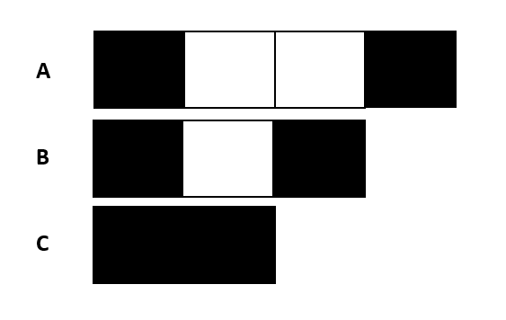

**EXERCICE 11: Encoding problem**

**Rules:**

* The white pixels have 0 to 2
* Black pixel always first and last cells

Question - Find an encoding

|  |  |  |
| --- | --- | --- |
| Meaning | Encoding to decimal | Encoding to binary |
| White | 0  1  2 | 00  01  10 |